**A Primer on Clearcoats**

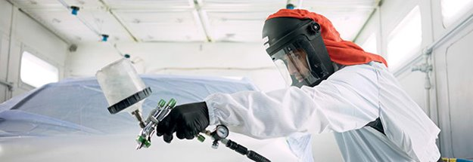

**What You Need to Know When Selecting the Right Clearcoat for the Job**

Whether you work in a high-volume, production-oriented collision repair facility or a custom-focused restoration business, choosing the right clearcoat for your work is critical for meeting your requirements and, more importantly, the customer’s expectations. This whitepaper provides a basic understanding of clearcoat technology, its role in providing a quality finish and the key factors that should be considered when selecting a clearcoat.

**The Clearcoat’s Important Role**

The adoption of basecoat-clearcoat finishes by OEMs in the early ‘80s represented a marked advance over single-stage color systems. By providing a coating over the base color, the clearcoat not only provides superior gloss, it protects the color from fading due to the sun’s damaging ultraviolet rays—as well as enhances appearance, scratch resistance and overall durability.

**Chemistry**

Refinish clearcoats are made up of urethane resin technology that’s cross-linked with an isocyanate hardener. Several chemistries comprise a clearcoat:

**Resin**

The resin is the foundation of any clearcoat and plays a significant role in how it sprays, how fast it cures, its hardness, its VOC content and its overall durability. Since the resin is designed to be cross-linked with an isocyanate hardener, correct mix ratio is critical to achieving the proper reaction. If not mixed properly it can create a host of problems. And of course, when spraying any paint product containing isocyanate, it’s essential that the proper respirator and safety equipment be worn.

**Additives**

This type of chemistry adds to the performance of the clearcoat in several ways. It can improve the atomization of the liquid to make it easier to apply and achieve better overall appearance with less orange peel. Additives can also affect how the clearcoat lays down–its flow and leveling characteristics.

**Catalysts**

Added in very small amounts, catalysts can speed up the reaction between the resin and the isocyanate hardener. The faster reaction however can shorten the clearcoat’s pot life and limits the window of time allowed to spray it. If the reaction is too fast, it may cause “solvent pop” or dieback by not allowing solvents to escape from the film before the curing takes effect.

**Solvents**

When added to the clearcoat, solvents help dissolve the resin, additives and catalysts to control the application and flow. A blend of solvents with varying evaporation rates is used. “Fast solvents” reduce the clearcoat’s viscosity and evaporate during atomization out of the spray gun. “Slow” or “tail” solvents stay in the film longer during the wetting of the substrate and allow the clearcoat to flow and level out properly.

**The Keys to Durability**

Two key elements contribute to a clearcoat’s durability: UV absorbers and film build. UV additives absorb damaging ultraviolet rays, much like sun blocker for your skin. However, UV protectants cannot do the job alone in ensuring durability.

**Film Build is Critical**

Film build is equally important to ensure long-term durability of the finish. Too low of a film build can lead to premature film failure, dieback and overall poor appearance. Too high of a film build can lead to solvent pop, dieback, and even potential adhesion failure.

A final film build in the range of 2-2.5 mils is most commonly recommended. Whether using a value or premium clearcoat, a film build below 2 mils will decrease durability. So before spraying any clearcoat on a job for the first time, it is recommended to measure film build on a test panel. This will help gauge how your application techniques affect final film thickness. Two coats should suffice in creating adequate film build if using a high-solids, premium clearcoat. Some value-priced clears may require three coats to achieve the same degree of protection.

Knowing the film build is especially critical if the job will later be buffed. In other words, one cannot apply a film build of 2 mils, then buff off a half mil. The result will leave not enough UV absorbers or resin solids to block out the ultraviolet rays, thereby compromising durability.

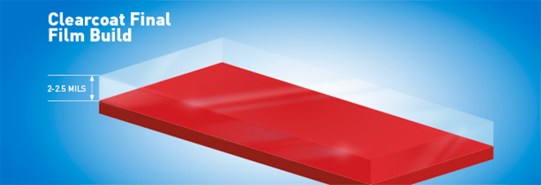

|  |
| --- |
|  |

**Causes of Common Defects**

**Solvent Pop**

This regretful defect occurs when the solvent gets trapped in the clearcoat and “pop” through the surface, creating tiny pinholes or pop marks. The cause can be due to many factors, such as using a solvent that’s too fast for the operating conditions, incorrect flash time between coats, too much film build, or incorrect spray pressure.

**Dieback**

The loss of gloss or matting after application can be also due to many factors: too fast a solvent, improper film build, or lack of proper flash time.

**Sags**

Usually occurring down a vertical surface, sags can be caused by application errors (too much at one time), or an incorrect mix ratio, whereby the solvent may not evaporate fast enough. Another cause is not allowing enough flash time between coats.

**Orange Peel**

A clearcoat having the textured look of an orange peel can result when applying the clearcoat at too great a distance; when incorrect air pressure causes the fluid to not atomize correctly, or if the solvent is too fast that it evaporates before the clearcoat is allowed to flow properly.

**Clearcoat Selection Guide**

Based on PPG Deltron® Clearcoats.

|  |
| --- |
|  |
| |  |  |  |  | | --- | --- | --- | --- | | **Air Dry / Express** | **Speed** | **Production / General Purpose** | **Glamour** | | “Must go!” Same day turnaround | Fastest throughput / Most popular | All-purpose / Everyday clear | Superior gloss / High temp & humidity | | Quick flash times | 3-5 min flash time | 5-10 min flash | Long flash times—10-15 min or more | | 30 min air dry | 90 min air dry | 4 hr air dry | Overnight dry | | Quick to buff | Short / Low bake option | Bake most common | Best suited for bake | | Spot—1 panel | 1-3 panels | Multi-panel jobs | Large jobs / Completes | |  |  |  |  | |

**Choosing the Right Clear for the Job**

Clearcoat offerings can be divided into four major categories, primarily based on their speed of application: Air Dry Express, Speed, Production and Glamour. The number of panels to be repaired is a prime factor in considering which clearcoat to use, with heat and humidity of the operating environment also a key consideration.

**Size of Repair**

The number of panels to be repaired should be the first consideration. If performing a spot, or one panel, repair, such as a bumper cover, an air dry, “express” clear is a good choice. This clearcoat is especially ideal when the job needs a fast one-day turnaround. Now let’s say the repair includes a bumper cover plus one panel or three panels. Here a “speed” clear can be a good choice. Its 3-5 minute flash time will open up the application window wide enough to apply two coats of clear. Some collision centers prefer a general purpose “production” clear to handle all types of repairs. This type of clearcoat offers adequate flash times to handle most multi-panel repairs. A “glamour” clearcoat is the fourth option and the right choice for large jobs or completes.

**Equipment**

Clearcoat choices become more limited if a paint booth lacks bake capability. The longer air dry times of production and glamour clears would significantly limit paint shop throughput, so express and speed clears offer the best options. A glamour-type clear is still recommended for large or overalls but would require an overnight dry.

**The Environment**

Every clearcoat has a prescribed flash time, air dry and bake standard that’s generally based on an operating environment of 70°F at 50% humidity. Conditions exceeding these temperature and humidity levels require the use of a clear with an extended application window. It’s a situation that’s especially common in the southern areas of the United States. For example, let’s say the job is a three-panel repair and the temperature has risen to 90°F and a humidity of 70-80%. Normally a speed clear would be the choice for this repair. But in this situation, a production or glamour clear, with their longer flash times, would be the recommended solution.

**Warranty Repairs**

Many OEMs are recommending approved refinish systems and procedures for warranty repairs. One procedure to pay particular attention to is the requirement to apply clearcoat from panel edge to panel edge. Blending or fading out the edge of the clearcoat is not permitted. In situations where there is no panel break line, one might have to apply clearcoat to the quarter panel, roof and opposite quarter to reach the final panel edge. Paint manufacturers also have standards to meet for warranty requirements. As an example, two coats of clear applied edge to edge with a film build of 2 mils after buffing is required to maintain PPG’s Lifetime Limited Paint Performance Guarantee for its premium clearcoats.\

**Final Appearance**

Some factory finishes have a higher degree of texture or orange peel than others, e.g., luxury vehicles tend to have smoother, glossier finishes. So matching texture is another factor in choosing a clearcoat. In general, a glamour or slower-drying clear will flow more after being applied and provide less orange peel than a speed or express clear. So getting the surface wet enough and controlling the texture is key to achieving good appearance and texture.

**Conclusion**

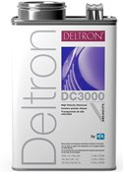In conclusion, there are many factors to consider when selecting and applying the right clearcoat for the type of the repair. Pay particular attention to the product’s recommended mix ratio and flash times and the temperature and humidity of the operating environment. Equally essential is maintaining a final film build of 2-2.5 mils to ensure long-term durability. Of course, like any refinish product, be sure read and follow the manufacturer’s technical and safety instructions.

With a flash time of 3-5 minutes and a 9-minute bake time, PPG’s Deltron® DC3000 is a good example of a speed clear that’s preferred by high-production shops.