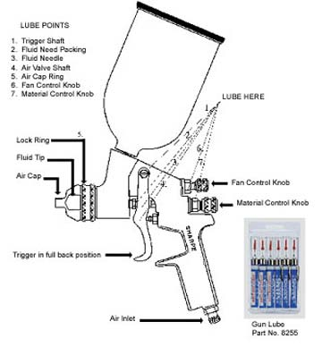**Lubrication & Maintenance**

1. The spray gun should be lubricated after every cleaning using gun lube. Place a drop on all moving parts, as shown in illustration.

2. Do not completely disassemble the gun if "spitting" or bad spray pattern occurs. See trouble shooting section for information on how to correct these problems.

3. Do not submerge spray gun in any solution normally used to clean a spray gun unless a complete overhaul is going to be done.

4. To clean spray gun, use the following procedure:

A. Remove all heavy paint from the gun and cup - replace with 3 to 4 oz. of compatible solvent. Percolate the spray gun as follows: Loosen the air cap and using 5 psi or less pull the trigger to the full back position, this action will force the material in the   
gun head back into the cup. Repeat this until the solvent runs clear.

B. Wipe off the outside of the spray gun and cup with compatible solvent. Blow-dry and lube.

5. Never use any hard objects such as a wire, paper clip, or welding tip cleaner, to clean the air cap orifices. The air cap is made of high alloy heat-treated aluminum and hard objects will damage the orifices.

To clean the air cap: Soak it in a compatible cleaning solution and use soft objects, such as a round wooden toothpick or medium bristle brush or reverse blow the passages.

**WARNING: The holes in air caps and fluid tips are machined to tight tolerances. Using a cleaning tool in these holes can distort those holes, which will distort your spray patterns. Always try using a solvent solution to dissolve any blockages first. If you must use a tool to push out the blockage, use the softest, least abrasive tool possible.**