Achieving a ‘No-Buffer’
The holy grail of the paint shop is a “no-buff” job”, and we it isn’t achieved by hope and prayer. So just how do we achieve it? We control what we can! And we can control most of the problems.

The Vehicle
The vehicle is a big source of contamination. Painting parts off the car has greatly reduced this. Some shops are even painting blend panels off the car, often allowing them to load the booth with two jobs at the same time. This technique achieves cleaner results because it allows better cleaning, prepping and masking.
Plastic parts create dirt issues because of the static electricity that builds as the part is cleaned and wiped. This is a greater challenge when humidity is low, but is always a factor to address. Anti-static wipes and solvents address the biggest part of this problem, but still, the very act of wiping creates some static in the plastic. The only way to completely eliminate this is with an anti-static gun.

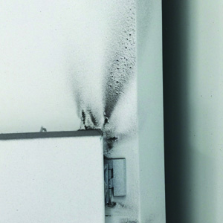
The Booth
Paint booths are designed to keep contaminants out, but poor maintenance and user habits can quickly eliminate that benefit. Here are some obvious and not so obvious ways to keep your booth functioning as it was designed.
- Keep the filters clean; intake and exhaust filters on all, serviceable plenum filters and pre-filters on those that are so equipped.
- Look for dirt intrusion in the seams and joints of the interior walls.
Evidence of a poorly sealed booth..

- Don’t open the doors without the booth running. Intake filters are statically charged from air running through them. They will attract the dirt onto them and release it in the air when the booth is turned on.
- It’s not a bad idea to wipe the walls with an old tack rag after loading a vehicle. It captures dust from the walls, plus it keeps overspray from building up.
- Clean the floor after each job, or at least daily, as a standard operating procedure.

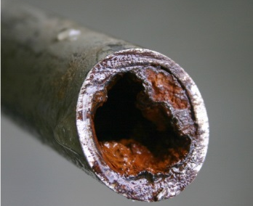
Air Lines
There are several ways your air lines can help to insure clean air. They are:
- Choose the right piping. These are your 4 basic choices:
  - PVC insulates the air, allowing moisture to stay in your air supply longer. It also tends to droop between hangers, creating dips where contamination accumulates and periodically surges through the air line. When that happens, it can overwhelm or plug any filters downstream.
This is what iron piping looks like after several years of use.

  - Iron piping also retains heat, which retains moisture, which corrodes the inside of the piping. This corrosion will begin to restrict air flow, and eventually it will break loose and migrate down the line carrying all of the moisture, oil and other debris with it.
  - Copper piping is a great choice for air lines. It is an excellent conductor of heat and is corrosion resistant. It keeps your air cooler and drier. And it maintains a dependable air flow over its life. Its downside is that it is expensive to buy and install.
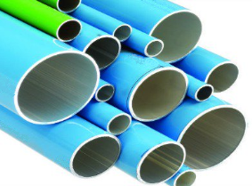
  - Aluminum piping has become the best choice for the paint shop. It conducts heat and resists corrosion well. It is much less expensive to buy and installation is simple with its push-on connectors.
Note: For many shops with PVC or Iron piping, we recommend that you upgrade.
Aluminum piping comes in all sizes, and is easy to install.

- Pipe for air, not for water. Basically, that means draw your air from the top of the pipe rather than the bottom. This greatly reduces the amount of water and contamination going to your filter and/or spray gun.
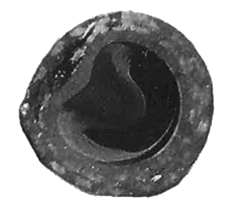
Compressed Air
- Maintain or replace your air hoses.
  - Air hoses break down due to age, high-bake temperatures, driving over it, or simply because it’s cheap. Evidence of this is tiny black spots seen in light colors. It requires replacement
  - Overspray buildup and crud get crusted along the last few feet of the air line, sometimes falling into the paint. Take a second to prevent this by wiping it down with an old tack rag.
Cross-section of an air hose that was driven over repeatedly.

- Choose the right air filter and maintain it.
  - Water Separators remove water, but not humidity. On high humidity days, that humidity will condense into fine water droplets when it comes out of your aircap. These are recommended only for your tool drops.
  - 3-Stage Desiccant Driers consist of a water separator/particle filter, an oil remover, and a desiccant drier. They will remove humidity from the air if maintained. But, if the desiccant material is not changed regularly, they quit working. And, if the water trap is not drained regularly, liquid water will flow into the desiccant drier and cause the desiccant material to rapidly deteriorate. These are recommended for your paint drops.
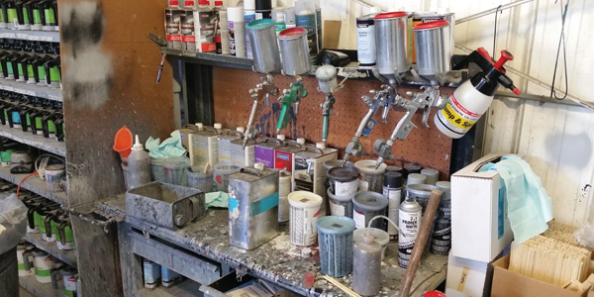
  - Refrigerated Air Driers reduce the humidity to near zero, but they are normally used in very large painting facilities. They are rarely needed if the rest of the air system is properly installed and maintained.

The Spray Gun (including couplers and regulators)
- Replace leaking couplers. They may blow contaminants of your sleeves or hoses.
- Keep the spray gun clean on the outside.
- Keep the spray gun clean on the inside. Internal film build up may release contaminants or restrict air flow.
The housekeeping habits of this painter speak loudly about his effort to achieve a clean paint job.

- Use clean gun cleaning solvents.
- Inspect the air cap for wet paint deposits immediately after spraying. A bad aircap/fluid tip/needle may cause it to periodically spit globs of paint on your surface.

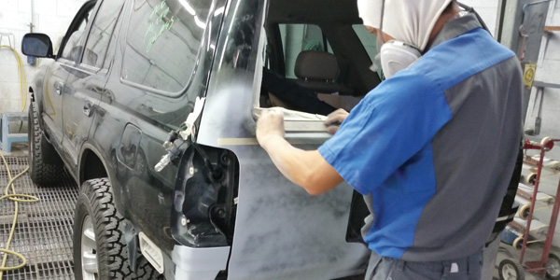
The Painter
Prepping to paint is like prepping for surgery. You want everything to be absolutely clean. And like a surgeon, you must suit- up before every operation and un-suit when it is over. These are common mistakes painters make:
- Doesn’t wear paint suit, head cover, gloves or shoe covers (PPE) while in the booth.
- Leaves on the paint suit, head cover, gloves or shoe covers after exiting the booth.
- Sands or buffs while wearing PPE.
- Doesn’t properly prepare the vehicle, booth, air lines or spray gun before taking them into the booth.
All of the recommendations above take time. But they pay for themselves with reduced buffing time, fewer redos, and less material used. Don’t be one of those people who doesn’t have time to do it right the first time, but has to find the time to do it over.

The Shop
A body shop is a dirty place. Vehicles, people, even the wind carry in dirt. Sanding, grinding, welding and cutting all produce contaminating solids and fumes. Aerosols put contaminants in the air. The body shop creates everything you don’t want in your paint shop. So, the best thing you can do is to separate your body shop operation from your painting operation as much as possible.

Acts of God
There are situations that defy predictability and therefore cannot be prevented. In the paint shop, most acts of God come in the form of bugs. They are attracted to the lights and the heat. We don’t have a lot of ideas on this one. Keep your eyes peeled for them before you spray. Kill them when you can. And remember the other 95% of buffing or repaint issues you did solve.

