Body fillers are used to straighten areas with slight dents. Clean out the area with 80 grit sandpaper. Mix the filler correctly (50:1), without trapping air in the mix. Slightly overfill the area, pressing the filler down firmly. Let it cure thoroughly and rough sand with 80 grit. Final sand with 180 grit. Inspect for pinholes or blemishes, which can be easily filler with body putty.

**# 1 PERSONAL SAFETY**

Most of the products you will be using in this effort can be harmful to your health. Some cause immediate harm, others accumulate. We know people who suffer because they ignored basic safety precautions. Protect yourself from fumes, dusts, mists, and splashes. Wear personal protection at all times.

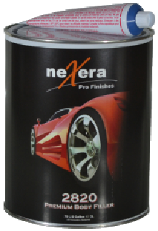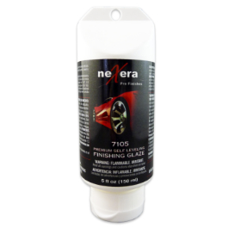

Contamination can play havoc with paint. There are 2 types of contaminants; water-based and oil-based. Clean the entire vehicle once with a water based solution, such as Dawn Dish Soap. Clean again with a Wax & Grease Remover. Clean again prior to applying the color coat.

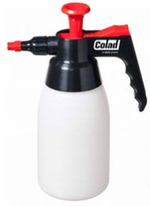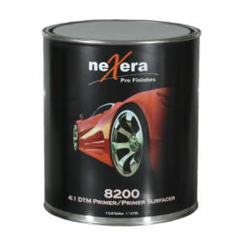

There are basically 3 types of primers.

***Lacquer primers*** are cheap, but are prone to many problems under today’s two component paint systems.

***Epoxy primers*** provide the best adhesion but are hard to sand. They also tend to spray out a little rough. Most epoxies today are modified to fix these problem.

***Urethane primers*** bite into existing finishes and are easy to sand. They also lay out very smooth.

*If you have a unique situation, we probably have a specialized primer to fill that need.*

Next, it is advisable to block sand the primer. Color and clear will highlight imperfections you will not see in the primer stage. Lightly mist a contrasting color over the entire area. Sand with hand block using 240 or 320 grit paper. While sanding, you will notice places where the mist remains. These are low spots. Sand until these spots are removed. Reapply primer on cut-throughs and repeat the block sanding process.

**# 5 LEVEL**

**# 4 PRIME**

**# 2 STRAIGHTEN**

**# 3 CLEAN TWICE**

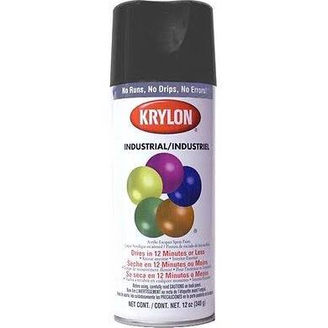

There are two general options for the color coat. ***Single Stage*** takes only a single step to apply, but it has many drawbacks. It is mostly used today for doing solid colors that require a “less than showroom finish.” ***Basecoat*** requires a clear coat for protection and gloss. There are many situations where you should use a Base/Clear paint, such as a showroom finish, a metallic or pearl finish, matching the paint on a 2000 or later vehicle, or applying more than one color or graphics to the vehicle. Some specialty paint jobs use even more coats, such as Candy jobs, Tri-coat jobs, and Ghost jobs. In these, you apply a foundation color coat followed by one or more transparent layers of specialty colors or effects. These types of paint jobs require the greatest level of knowledge and skill to apply in order to achieve the desired effects.

**# 6 COLOR COAT**

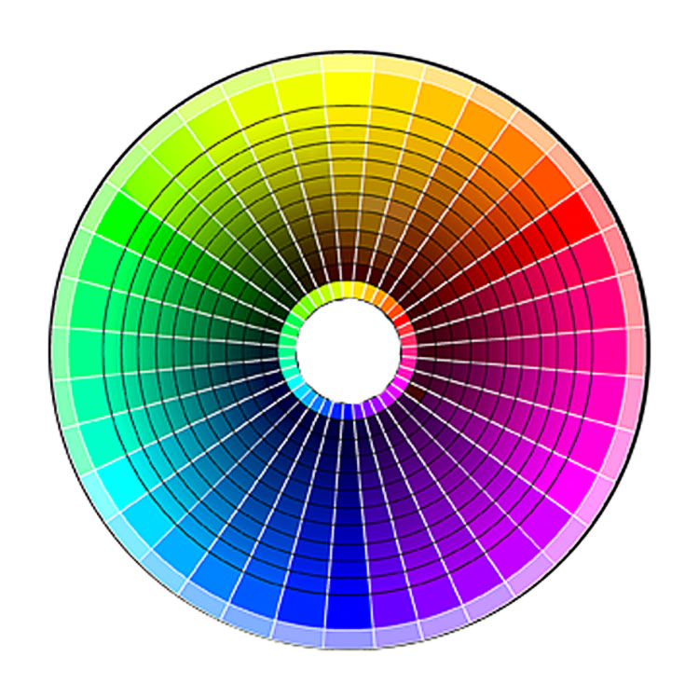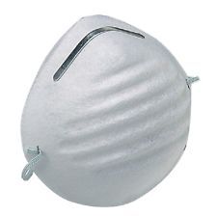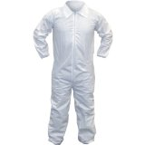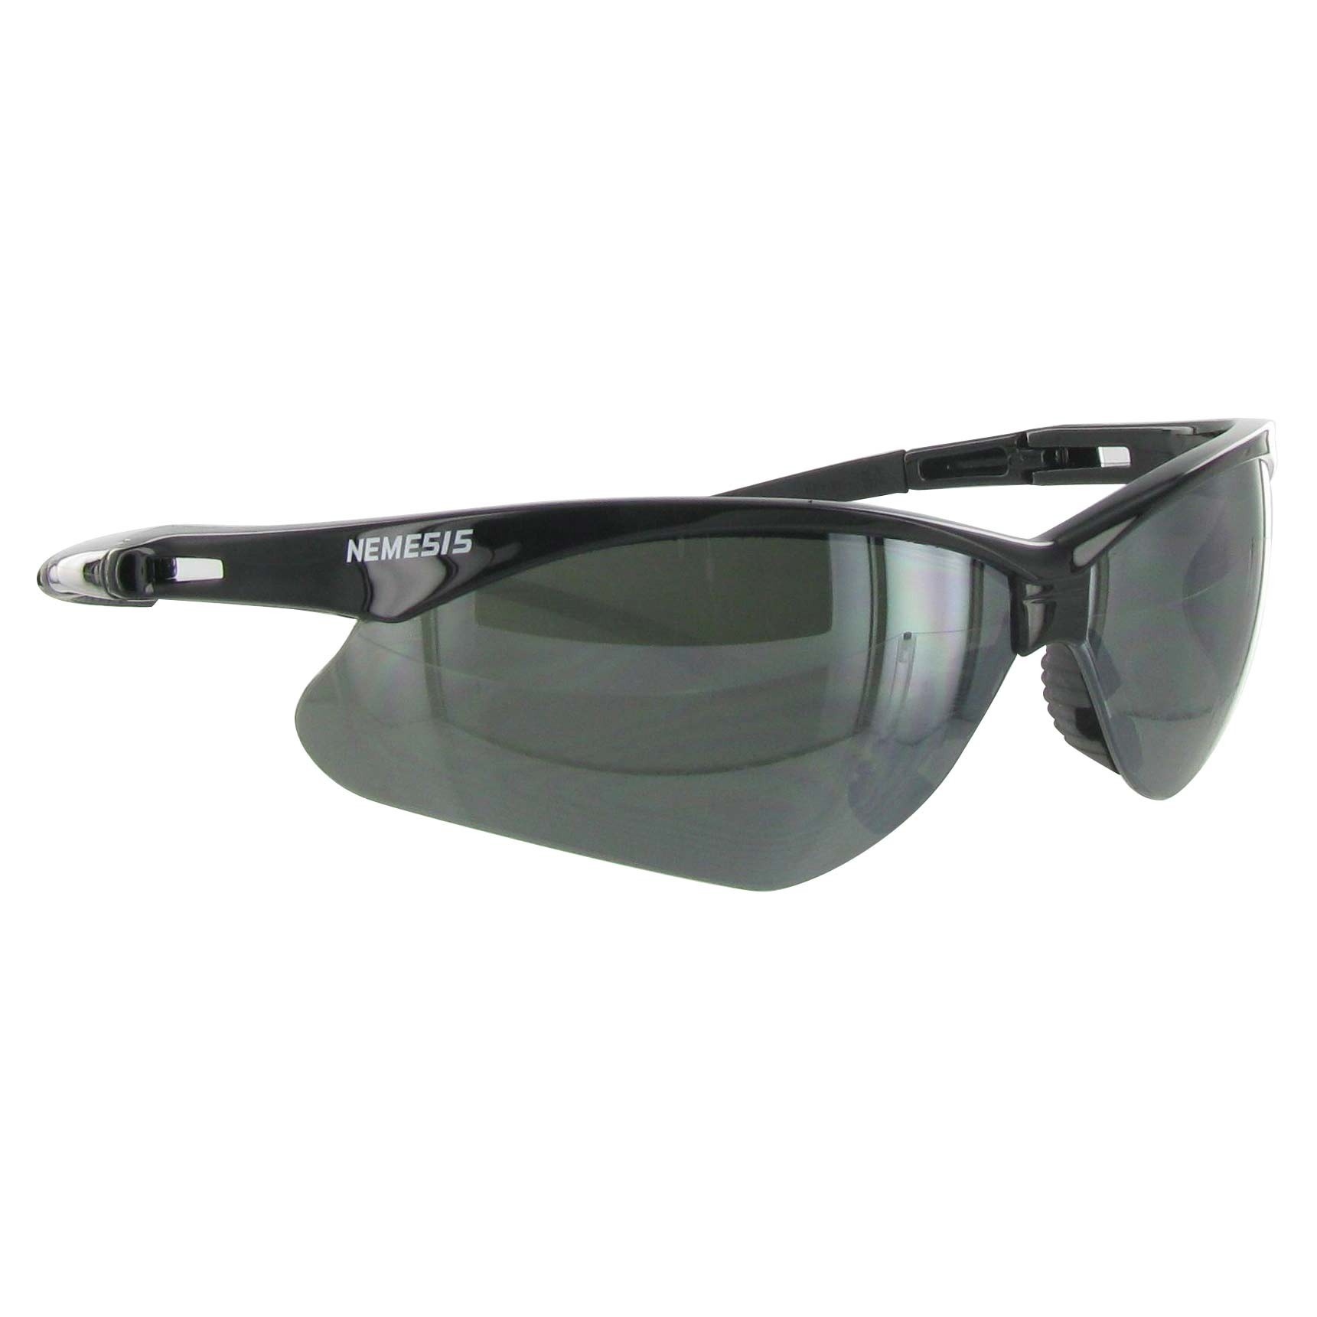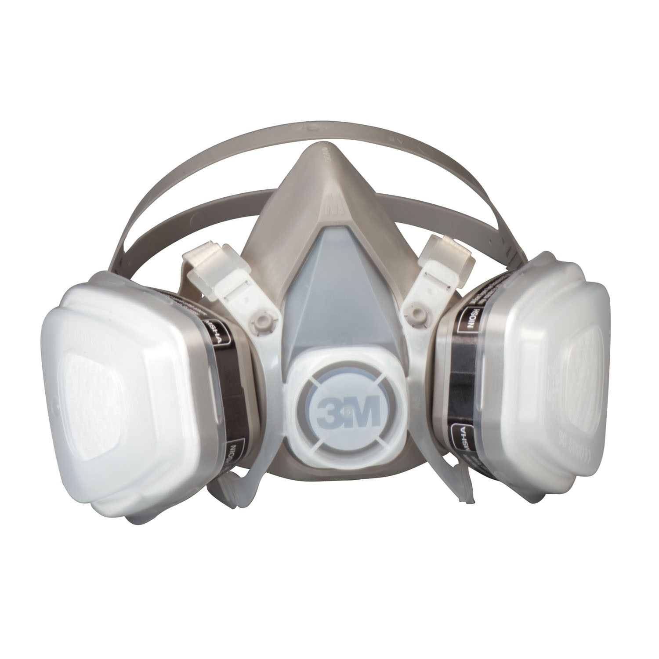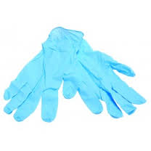

This stage will make or break your paint job. Choose the right clear for your intended purpose. Use the correct activators and/or reducers for the temperature in which you will be spraying. Follow the recommendations carefully for flash times between coats. Make sure you apply an adequate amount of clear, since most clear failures are the result of too little clear on the surface. After drying, color sanding, compounding and buffing, there must be at least 2 mils of clear remaining. 2.5 mils would be even better.

**# 7 CLEAR**

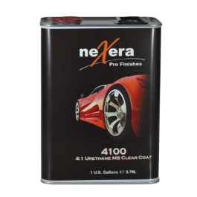

The final step is to remove imperfections and to fully bring out the gloss and depth of the clearcoat. Choose your products carefully. Better yet, tell us what you face and let us recommend the right methods to fix them.

**# 8 FINISHING**

